

MUUGLines
The Manitoba UNIX User Group Newsletter
Volume 31 No. 3, November 2018 Editor: Katherine Scrupa
Next Meeting: November 13th, 2018

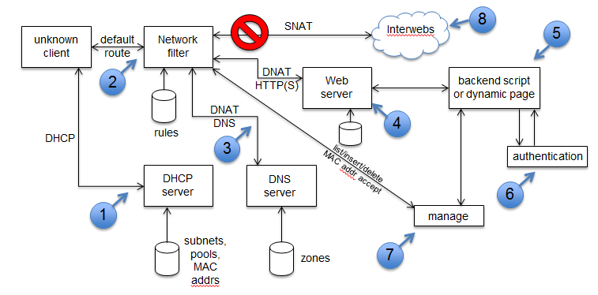
Build an IP Captive Portal from Scratch
(For Fun and Education, but Not for Profit)
Love ’em or hate ’em, captive portals are widely used to restrict Internet access to authorized users. What if you need to set one up, but all the “canned” solutions aren’t quite right for your use case? This presentation by Gilbert Detillieux will show you the various components that make up a captive portal, and how you can set one up from scratch, using Linux Netfilter/iptables, the Apache web server, ISC DHCPD and BIND, and some custom back-end scripting.

RTFM: date
The lowly date(1) command has been a fixture of UNIX systems from the very early days. Yet there may be features in this command that would surprise you. Adam Thompson will present this RTFM.

The latest meeting details are always at:

https://muug.ca/meetings/
Creative Commons License

Except where otherwise noted, all textual content is licensed under a Creative Commons Attribution-ShareAlike 4.0 International License.

https://creativecommons.org/licenses/by-sa/4.0/
Where to Find the Meeting

University of Winnipeg, Room 1M28
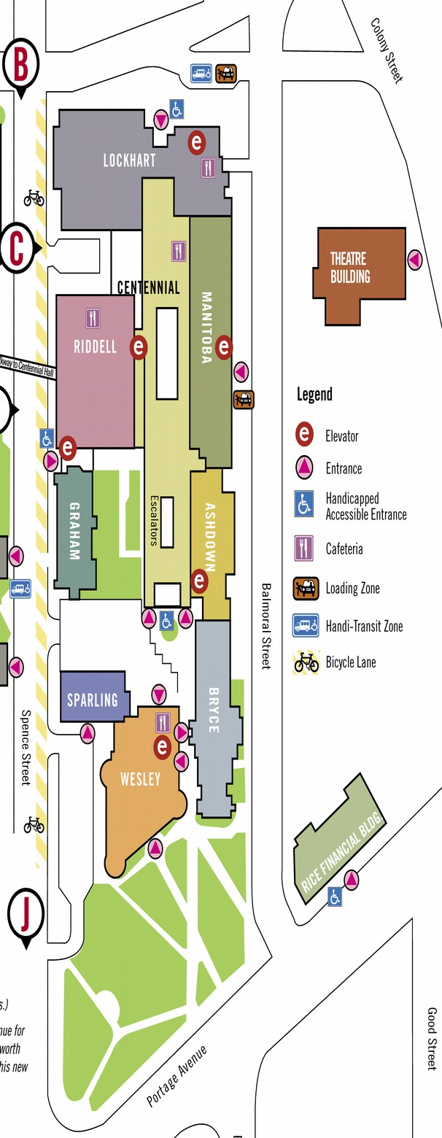
Meetings are held in the University of Winnipeg’s Centennial Hall, in the middle of the University Complex.
We can be found in
room 1M28.
Doors are usually open by 7:00 pm with the meeting starting at 7:30 pm. Parking is available on the surrounding streets and in the parkade above the bus depot across Balmoral Street. See uwinnipeg.ca/maps for further information about parking and access to the campus.
Door Prizes!
As usual we will have some e-books to give away this month.
We will be giving away a position on the board to one lucky member!
2017-2018 MUUG Board Elections

Help us promote this month’s meeting, by putting this poster up on your workplace bulletin board or other suitable public message board:

https://muug.ca/meetings/MUUGmeeting.pdf
Adam Thompson, Nomination Committee Chair
(By the time you read this, nominations for this year’s MUUG Board election will have closed.)
Every November, the group holds its Annual General Meeting. The main goals of the meeting are to elect the new board, and to pass any special resolutions, if required. The Board may consist of up to nine (9) people.
Those elected will serve on the MUUG board from November 2018 to November 2019. Any MUUG member in good standing may nominate someone they feel would make a good candidate, including themselves.
The MUUG Board is tasked with coordinating the meetings and other events hosted by the group. It’s fun, and you get a role in deciding what the group will do. All members are encouraged to apply.
The following 8 members are allowing their names to stand for re-election. (Election will be by acclamation if the number of members running is less than the number of available board positions.)

Trevor Cordes
Owner
Tecnopolis Enterprises

Trevor Cordes (B.Sc. CompSci) has owned and operated Tecnopolis Enterprises, a computer VAR, programming and consultancy company, since 1999. Linux and FOSS have been the keystone of Tecnopolis since inception, embodied in their flagship do-everything appliances for small business. Trevor was President of the Atari ST User’s Group for four years, between 1995-1999. He prefers Fedora and Perl.

Gilbert Detillieux
Systems Analyst
University of Manitoba

Gilbert Detillieux has been working with UNIX as a programmer, system administrator, and trainer since 1980. He worked as a computer consultant specializing in UNIX, from 1983 to 1989, and is currently working as a Systems Analyst for the University of Manitoba’s Department of Computer Science, where’s he’s worked since 1989, installing, supporting and upgrading the department’s network and UNIX server infrastructure. He was co-founder and past president of the Technical UNIX User Group (now MUUG), and has been an active member of the MUUG board ever since.

Kevin McGregor
Systems Administrator
City of Winnipeg

Kevin McGregor provides server, platform and infrastructure support in the City of Winnipeg’s Information Systems Department. After having briefly used UTS on an Amdahl mainframe in university in the mid-80s, he dabbled in Coherent and then converted to Linux and OpenBSD. He has been a member of MUUG since the early 90s, edited the group’s newsletter for a number of years, presented various topics at MUUG meetings and has served on the board for the majority of his membership.

Katherine Scrupa
LAN Administrator II
Steinbach Credit Union

Katherine has been a member of MUUG since 2006, during which she has been using Linux at home. Her educational pursuits in Computer Science led her to a Network Technology CCNA (Hons.) program at Red River College in 2010, with an emphasis on networking and system administration. Katherine's current work comprises of root cause analysis, configuration management, automation, and security.

Adam Thompson
Senior Systems Administrator
Avant Systems Group

Adam first unknowingly used UNIX in 1988, while playing NetHack on the QNX BBS in Ottawa, which gave him a huge advantage the first time he encountered vi(1)! He first ran into UNIX professionally in 1990, and started using Linux in 1991. Adam is the author of several termcap(5) and terminfo(5) entries, deployed the first cross-platform, public, networked instantmessaging system in Manitoba, and installed the first UnixWare system in Manitoba. He has developed several UNIX/Linux courses, and has also taught RDBMS administration. Adam has been a member of MUUG since 1995, and a board member for over a decade. Adam currently attempts to make multiple versions of Linux, Windows, Solaris and BSD all play together nicely, in between working on customer installations of Atlassian software and making virtualization environments do his bidding.

Tyhr Trubiak
Systems Administraor
Thorkelson Consulting

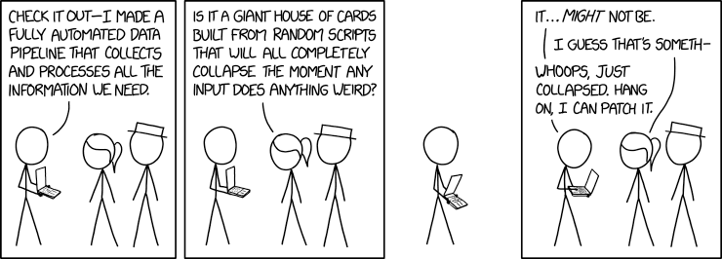
Tyhr Trubiak has been a member of MUUG since 2013. He manages a mix of Red Hat/CentOS and OpenSUSE servers within VMWare, as well as some Windows and Cisco devices. His first exposure to UNIX was when he received his B.Sc. CompSci at the University of Manitoba, which he found similar to his first love - the Commodore Amiga. He hasn’t found a desktop distro he’s liked enough to remain loyal to since, but is currently testing Elementary OS on his laptop. He has enjoyed 2D node-based digital compositing in the past (Blackmagic Fusion, formerly known as Eyeon Fusion), acting and anything Jeep related.

Brad Vokey
Owner
Fortress Software

Brad is the owner of Fortress Software Inc. And the creator of the Matchmaker Fundraiser (aka “Matchomatics” - a fundraiser that provides compatibility lists for millions of students across Canada and the US). Brad started the company in 1985 using Apple ][ computers and 6502 machine language. Then switched to 68000 machine language on Atari ST computers in 1986 and then to C on Atari TT030 computers soon after. The original C program and Atari TT030 computers are still very much alive and in use to this day! In 2004, Brad started using Linux on Tecnopolis servers, and joined MUUG in 2006. He previously served on the board of the Atari ST Users Group (STUG) and became a board member of MUUG in 2011. He has been keeping our finances in order as your MUUG treasurer since 2013.

Wyatt Zacharias
Unix/Linux and Network Administrator
Manitoba Blue Cross

Wyatt Zacharias is a system administrator at Manitoba Blue Cross. He manages a mix of RedHat Linux and HP-UX servers, as well as Cisco routing and switching gear and enterprise firewall appliances. Wyatt has been president of MUUG for the previous three years, and served as vice-president the year before that. Wyatt graduated from Red-River college in 2014, and is a RedHat certified engineer.
DoH!
DNS security is making some headway. DNS Queries over HTTPS (DoH) (yes really) is now RFC 8484.

https://www.rfc-editor.org/rfc/rfc8484.txt
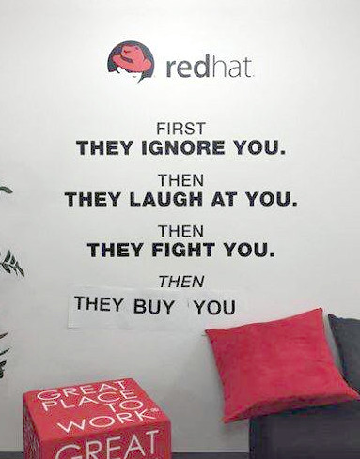

Big Blue Red Hat?

https://arstechnica.com/information-technology/2018/10/ibm-buys-red-hat-with-eye-on-cloud-dominance
Strange Things on Honeypots
“echo I’m sorry but I’m mining on your device not because I want to but because I need the cash. I am truely sorry but currently I can’t find or get any job...”

https://twitter.com/stefant/status/1053227806258327558/photo/1
X.org CVE-2018-14665
This bug allows privilege escalation on Linux and BSD distros.
“Incorrect command-line parameter validation in the Xorg X server can lead to privilege elevation and/or arbitrary files overwrite, when the X server is running with elevated privileges (i.e. when Xorg is installed with the setuid bit set and started by a non-root user).
The -modulepath argument can be used to specify an insecure path to modules that are going to be loaded in the X server, allowing to execute unprivileged code in the privileged process.
The -logfile argument can be used to overwrite arbitrary files in the file system, due to incorrect checks in the parsing of the option.”
More details:

https://lists.x.org/archives/xorg-announce/2018-October/002927.html

https://www.bleepingcomputer.com/news/security/trivial-bug-in-xorg-gives-root-permission-on-linux-and-bsd-systems

https://twitter.com/ErrataRob/status/1055607484084305921
Systemd DHCPv6 Buffer Overflow Allows Malicious Code or Causes Crash
A vulnerability in the dhcp6 client of systemd allows a malicious dhcp6 server to overwrite heap memory in systemd-networkd. Affected releases are systemd: versions up to and including 239.

https://www.theregister.co.uk/AMP/2018/10/26/systemd_dhcpv6_rce
MUUG has gone social!


Twitter:
twitter.com/manitobaunix


Facebook:
facebook.com/ManitobaUnix

Meetup
meetup.com/Manitoba-UNIX-User-Group
Sponsors

A big thanks to Les.net for providing MUUG with free hosting and all that bandwidth! Les.net (1996) Inc., a local provider of VoIP, Internet and Data Centre services, has offered to provide a 10% discount on recurring monthly services to MUUG members. Contact sales@les.net by email, or +1 (204) 944-0009 by phone, for details.
https://les.net/

