
MUUGLines
The Manitoba UNIX User Group Newsletter
Volume 29 No. 10, June 2017 Editor: Bradford C. Vokey
Next Meeting: June 13th, 2017

Presentation: BSDCan 2017 Report

Adam Thompson will be reporting on his recent visit to the 14th annual BSDCan.
BSDCan, a BSD conference held in Ottawa, Canada, quickly established itself as the technical conference for people working on and with 4.4BSD based operating systems and related projects. The organizers have found a fantastic formula that appeals to a wide range of people from extreme novices to advanced developers.

Daemon-Dash: rsync
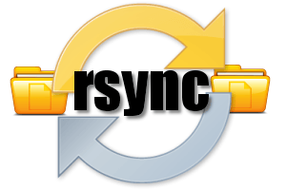
In the Daemon-Dash segment, Wyatt Zacharias will demo the rsync daemon.
When run as a daemon, rsync allows clients to directly connect and retrieve files, without the need for SSH encapsulation or shell access.

The latest meeting details are always at:

https://muug.ca/meetings/

Help us promote this month’s meeting, by putting this poster up on your workplace bulletin board or other suitable public message board:

https://muug.ca/meetings/MUUGmeeting.pdf
Where to Find the Meeting

University of Winnipeg, Room 2L17
SAME NEW ROOM
AS LAST MONTH
Meetings are held in the University of Winnipeg’s Lockhart Hall, along Ellice Avenue, West of Balmoral. We can be found in room 2L17 (the same room as last month). That’s the second floor. Elevators and stairs are available in Lockhart and Manitoba Hall. Doors are usually open by 7:00 pm with the meeting starting at 7:30 pm. Parking is available on the surrounding streets. See uwinnipeg.ca/maps for further information about parking and access to the campus.
Dazzling Door Prize This Month!
This month, in addition to our regular ebook giveaways, we will be giving away the O'Reilly book:

Masterminds of Programming
Conversations with the Creators of Major Programming Languages
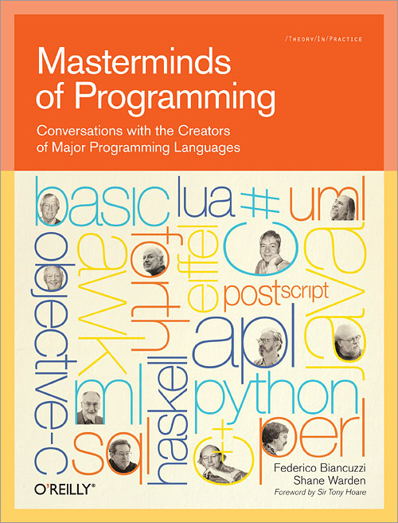
Masterminds of Programming features exclusive interviews with the creators of several historic and highly influential programming languages.
In this unique collection, you’ll learn about the processes that led to specific design decisions, including the goals they had in mind, the trade-offs they had to make, and how their experiences have left an impact on programming today. Masterminds of Programming includes individual interviews with:
- Adin D. Falkoff: APL
- Thomas E. Kurtz: BASIC
- Charles H. Moore: FORTH
- Robin Milner: ML
- Donald D. Chamberlin: SQL
- Alfred Aho, Peter Weinberger, and Brian Kernighan: AWK
- Charles Geschke and John Warnock: PostScript
- Bjarne Stroustrup: C++
- Bertrand Meyer: Eiffel
- Brad Cox and Tom Love: Objective-C
- Larry Wall: Perl
- Simon Peyton Jones, Paul Hudak, Philip Wadler, and John Hughes: Haskell
- Guido van Rossum: Python
- Luiz Henrique de Figueiredo and Roberto Ierusalimschy: Lua
- James Gosling: Java
- Grady Booch, Ivar Jacobson, and James Rumbaugh: UML
- Anders Hejlsberg: Delphi inventor and lead developer of C#
If you’re interested in the people whose vision and hard work helped shape the computer industry, you’ll find Masterminds of Programming fascinating.
As a reminder, door prize entry is free to every attendee, even non-members. The first draw will select from members only. Subsequent draws will select from all entrants.
Perl 5.26.0 released
The Perl 5.26.0 release is out.
“Perl 5.26.0 represents approximately 13 months of development since Perl 5.24.0 and contains approximately 360,000 lines of changes across 2,600 files from 86 authors”.
New features include indented here-documents, the ability to declare references to variables, Unicode 9.0 support, and the removal of the current directory (“.”) from @INC by default.
Full details:

https://metacpan.org/pod/release/XSAWYERX/perl-5.26.0/pod/perldelta.pod
$1,000 worth of Free Credit Card Processing!
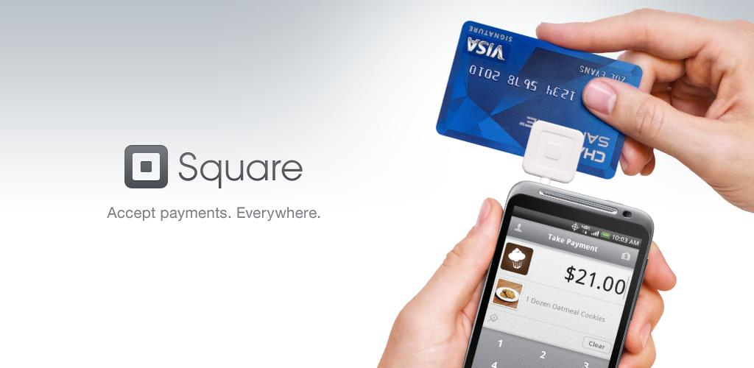
Ever wanted to start aceepting credit cards for your own needs?
Now it’s FREE! Sign up with Square (the credit card processor that MUUG uses at our monthly meetings) with the referral link below and both you and MUUG will receive $1,000 in free processing for the next 6 months (180 days).
You must use the following referral link for MUUG to receive the credit:

https://squareup.com/i/360D2122
Intel’s New Core i9 Extreme Edition CPU is an 18-core Beast

Last year at Computex, Intel unveiled its first 10-core consumer CPU, the company’s move into the world of a
“megatasking.” It was a pricey chip, launching at around $1,700, but it satisfied users who needed to juggle several intensive tasks at once.
Now, Intel is upping the ante with a new family of processors for enthusiasts, the Core X-series, and it’s anchored by the company’s first 18-core CPU, the i9-7980XE.
Priced at $1,999, the 7980XE is clearly not a chip you’ll see in an average desktop. Instead, it’s more of a statement from Intel. It beats out AMD’s 16-core Threadripper CPU, which was slated to be that company’s most powerful consumer processor for 2017. And it gives Intel yet another way to satisfy the demands of power-hungry users who might want to do things like play games in 4K while broadcasting them in HD over Twitch. And, as if its massive core count wasn’t enough, the i9-7980XE is also the first Intel consumer chip that packs in over a teraflop’s worth of computing power.
Automotive Grade Linux Debuts on the 2018 Toyota Camry

Automotive Grade Linux (AGL), a collaborative cross-industry effort developing an open platform for the connected car, announced on May 31st that Toyota has adopted the AGL platform for Toyota’s next-generation infotainment system. The 2018 Toyota Camry will be the first Toyota vehicle on the market with the AGL-based system in the United States.
“The flexibility of the AGL platform allows us to quickly roll-out Toyota’s infotainment system across our vehicle line-up, providing customers with greater connectivity and new functionalities at a pace that is more consistent with consumer technology,” said Keiji Yamamoto, Executive Vice President, Connected Company of Toyota Motor Corporation. “Adopting an open source development approach has enabled us to focus resources on developing innovative new features and bringing them to market faster.”
Find MUUG on these Social Networks:
 https://muug.ca/meetings/video
The first AGL-based Toyota infotainment system will debut on the 2018 Toyota Camry in the U.S. late this summer, and it will roll out to most Toyota and Lexus vehicles in North America.

https://www.automotivelinux.org
Thank You Les.net
A big thanks to Les.net for providing MUUG with free hosting and all that bandwidth! Les.net (1996) Inc., a local provider of VoIP, Internet and Data Centre services, has offered to provide a 10% discount on recurring monthly services to MUUG members. Contact sales@les.net by email, or +1 (204) 944-0009 x2 by phone, for details.


https://les.net/
Sort while you sleep!
an O(wtf) sorting algorithm
The sleep sort was presented anonymously on 4chan about 6 years ago:
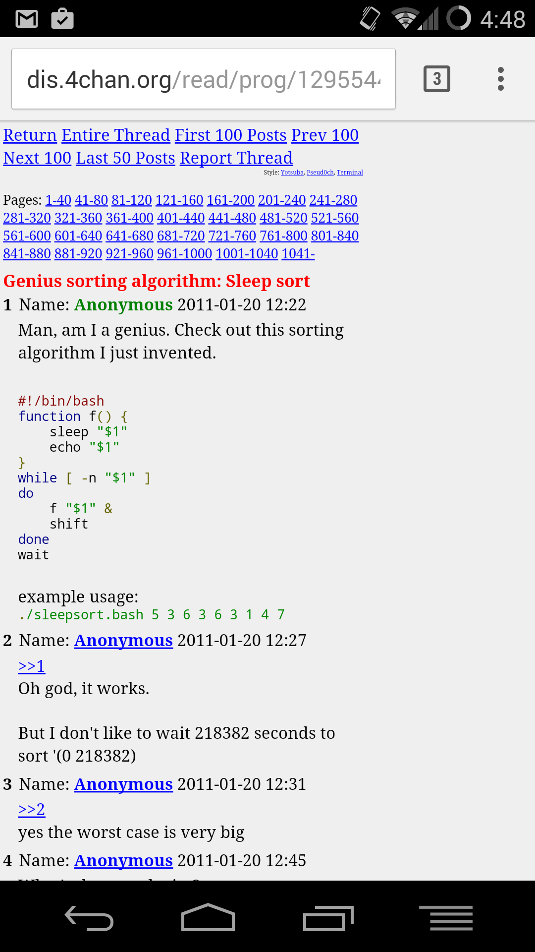
What’s cool is comparing all the diferent ways each programming language can code it:

https://rosettacode.org/wiki/Sorting_algorithms/Sleep_sort
And of course Perl (especially Perl6) wins for tersness:
await map -> $delay { start { sleep $delay ;
say $delay } }, <6 8 1 12 2 14 5 2 1 0>;
Vinyl Stickers
MUUG continues to give away free vinyl stickers with our shell logo: show up and grab a couple. They look great on laptops, or use them to promote MUUG around your office or school!
Except where otherwise noted, all content in this newsletter is licensed under a Creative Commons “Attribution-ShareAlike 2.5 Canada” License.

http://creativecommons.org/licenses/by-sa/2.5/ca/deed.en_CA

Your Summer Math Homework

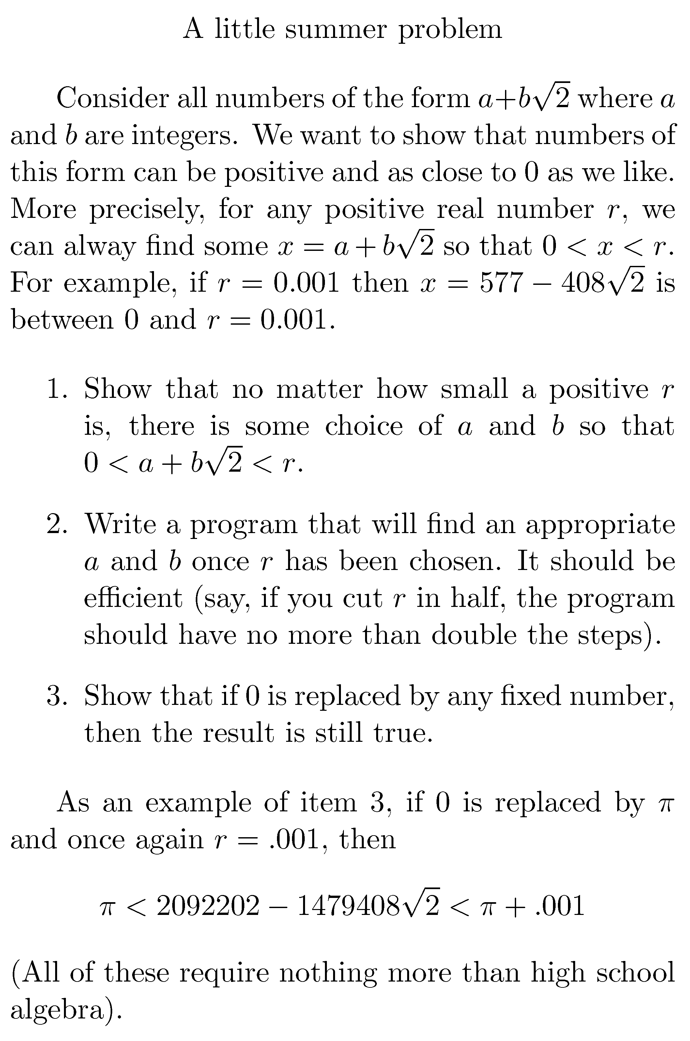
by Michael Doob (the answer will be published in September...)
Use Google’s AI to add voice commands to your Raspberry Pi
New hardware available in the official Raspberry Pi magazine makes it easy as pie
As part of an ongoing initiative to make its AI tools accessible to digital tinkerers, Google is teaming up with the creators of the Raspberry Pi. A new hardware accessory called the “Voice HAT” adds stereo microphones to the credit card-sized computer, and helps anyone use Google’s Assistant to control Pi-powered projects.
With a Voice HAT and Raspberry Pi, Google Assistant can answer all the usual queries, talking to users about things like the weather and sports scores. But it can also be used to add natural voice commands to other DIY projects. This could mean making a Pi-powered robot that follows your instructions (“robot, pass the butter”) or a Pi-powered mirror that you can chat to in the morning (“magic mirror, what’s my commute like?”).

https://www.theverge.com/circuitbreaker/2017/5/4/15541136/google-assistant-raspberry-pi-sdk-voice-hat
Dating a programmer/SysAdmin


