
MUUGLines
The Manitoba UNIX User Group Newsletter
Volume 29 No. 8, April 2017 Editor: Wyatt Zacharias
Next Meeting: April 11, 2017 7:30pm
RTFM: man – Brad Vokey
Brad Vokey will present man – the UNIX manual page viewer. Additionally Brad will show how to quickly create a basic man page on your own.
Presentation: BTRFS – Paul Sierks
Paul Sierks will present BTRFS – the B-Tree filesystem. BTRFS is a copy-on-write filesystem that brings a number of improvements over the typical journaled filesystem and adds features previously missing such as snapshots, checksumming and pooling.

Door Prizes:
This month we will continue giving away from our assortment of e-books from O’Reilly and No Starch Press.

Where to Find the Meeting
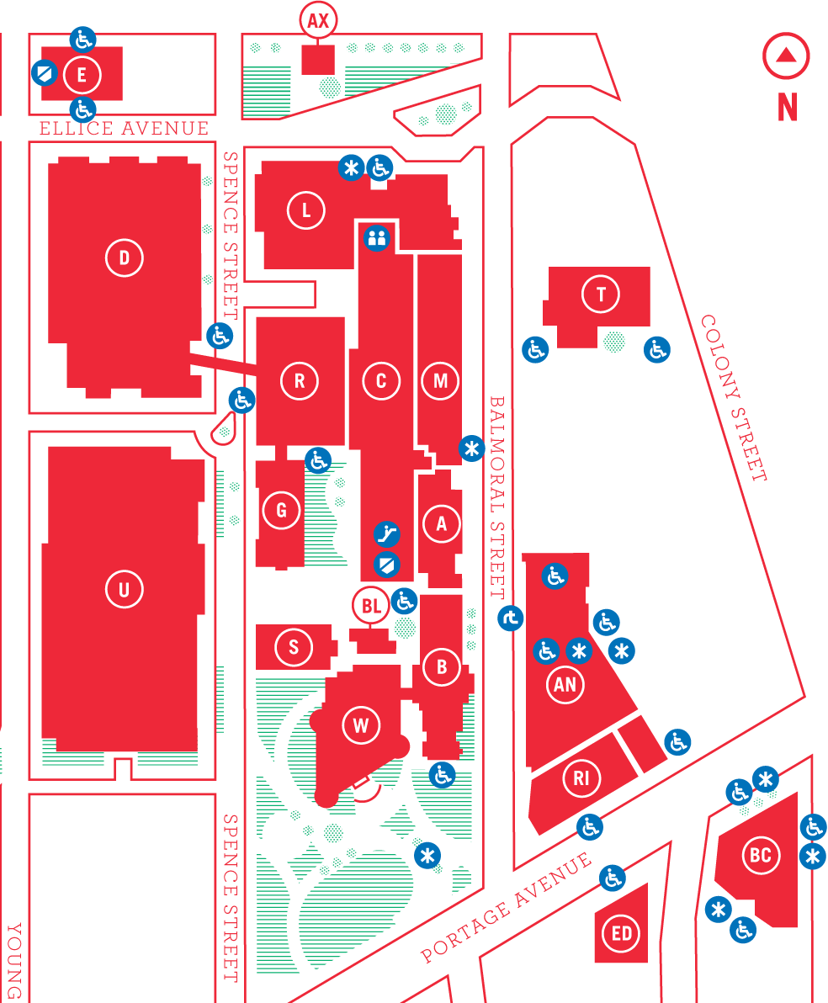

This Month’s Meeting

1L11 Lockhart Hall
This month’s meeting is in Lockhart Hall. Look for a sign on the door. There are elevators and escalators scattered around the buildings. A convenient one might be the elevator located right at the Ellice Ave entrance. Doors are usually open by 7:00 pm with the meeting starting at 7:30 pm. Parking is available on the surrounding streets. Please see

http://www.uwinnipeg.ca/maps
for further information about parking and access to the campus.
The latest meeting details are always at:

https://www.muug.mb.ca/meetings
WikiLeaks Publishes Massive Collection of Documents Detailing U.S. CIA “Vault 7” Hacking Tools
On March 7th, 2017, WikiLeaks began publishing a series of documents dubbed “Vault 7” containing details on the U.S. Central Intelligence Agency’s abilities and activities regarding electronic surveillance and cyber warfare. The source of the leak is currently unknown, however, Wikileaks said that the information “circulated among former U.S. government hackers and contractors in an unauthorized manner, one of whom has provided WikiLeaks with portions of the archive.”
Among the documents are details on U.S. cyber warfare activities taking place in Europe, Asia, and the Middle East. According to the documents, the U.S. operates out of the Consulate General Office in Frankfurt, housing agents for multiple agencies including the CIA, NSA, and Department of Homeland Security.
The leak also included information on “UMBRIDGE”, reportedly a massive collection of tools and vulnerabilities that the CIA had collected from other hackers. UMBRIDGE includes instructions on the tools’ use and the source code for the tools contained in a git repository.
As many have suspected, the leak contains information detailing the CIA’s use of internet connected consumer devices as surveillance tools by using undisclosed vulnerabilities in these devices in order to gain control. The documents suggest that the CIA has targeted Samsung Smart TVs for use as remote listening devices, as well that they have functioning exploits for both Apple and Android devices.
AMD Releases New “Ryzen” Processor Line
Announced on Dec 13th, 2016, AMD has now released their latest CPU line, which features their new Zen microarchitecture, and is based on a 14nm process. AMD has stated that their primary goal while designing the Zen architecture was to improve per-core performance.

Ryzen uses the latest AM4 CPU socket along with DDR4 memory. Currently AMD is only offering CPUs with the Zen architecture as desktop processors, however, they have stated plans to offer it in an APU and Opteron line.
OpenSSL Moves to Re-License with Apache License v2.0

Announced in a blog post on March 22nd, the OpenSSL project is planning to re-license their source code under the Apache v2.0 software license. The project currently uses a custom written license that contains some unusual clauses in regards to an open software license. The maintainers hope that the new license will promote further use of the product in other FOSS projects.
Of course not everyone is excited about the change. Theo de Raadt, founder of the OpenBSD project and a major previous contributor to OpenSSL posted to the OpenBSD mailing list expressing his distaste with the behaviour of the maintainers, stating “They have never asked the community of authors what they want. I think OpenSSL are using a github ‘garbage-in / garbage-out’ style of process. Feel free to dig into what they think I am author of, and why. The start suggests they want to privately collect sufficient consensus to pass their agenda. They appear to be considering all actions in the tree (including mine) on equal grounds. The last sentence suggests they don’t care at all about the rights of the authors.”

https://goo.gl/mLskCh

https://goo.gl/04EQeC
Canada Revenue Agency Public Webserver Compromised Through Apache Struts Vulnerability
The web server for the Canada Revenue Agency was recently taken offline in order to patch a vulnerability in Apache Struts that had already been used to compromise the server.
In a press conference the government confirmed that Struts was the cause of the hack, however, they pressed that only publicly available information was taken from the server. Cisco and VMWare have also issued advisories for certain products that may be vulnerable to attack.

https://goo.gl/t1WXAE
Google Releases First Beta Version of Android O
Google has released their first developer preview of Android O, the latest major version of the mobile operating system.

The new release has many new features, with a focus on battery life and multi-tasking. Building on the work in Nougat, O introduces more strict limits on what apps can do in the background, with the main areas of focus being implicit broadcasts, background services, and location updates.
O also introduces a new picture-in-picture functionality, allowing a user to keep a video playing while performing other tasks.

https://goo.gl/vynWgY
Netflix Now Available to Firefox on Linux

In August 2016, Firefox gained the necessary DRM modules in order to play Netflix streams with their HTML5 player, but although Firefox supported the DRM, Netflix still did not officially support the browser on Linux. Not being a supported browser meant that users were forced to spoof their user-agent in order to watch the streams. Now Firefox users will enjoy easy streaming access to Netflix on Linux.

https://goo.gl/F2ihLP
Dell Offers Five New Laptops with Ubuntu 16.04 Pre-Installed
Since 2007 Dell has been offering “developer” versions of select laptop models with Ubuntu Linux as the pre-installed operating system.
Their latest offering of developer editions includes models from their XPS and Precision lines offered with Intel Core and Xeon processors.

https://goo.gl/TqOf6o
Blackmagic Design Releases Their Video Editor and Colour Correction Tool DaVinchi Resolve for Linux
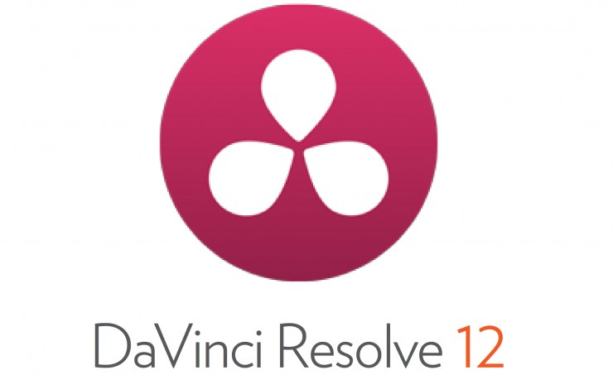
DaVinchi Resolve has been a popular free colour correction and video editing tool offered by BlackMagic Design for Windows systems. BlackMagic has announced they will now be offering the tool for Linux users as well.
DaVinci Resolve is considered by many to be a de-facto standard for colour correction and its move to Linux brings us one step closer to proper Linux multimedia capabilities.

https://goo.gl/SeMZzy
Firefox Drops Support for ALSA, Now Supports PulseAudio Only
As of version 52, Firefox has made PulseAudio a hard dependency for audio functionality with the browser. Mozilla cites the lack of a developer capable and willing to maintain the Alsa components of Firefox as the reason for its removal. Some users, however, were caught off guard by the change as there was no mention of the removal in the release notes of the version. The only mention of Alsa’s removal was in a blog post in 2016.

https://goo.gl/xc4hbx
ChromeOS Obtains Double the Desktop OS Market Share of Linux
According to StatCounter’s February 2017 desktop report, Google’s ChromeOS has now gained twice the market share of Linux, with 3.36% versus Linux’s 1.47%. It isn’t all bad news for Linux though, its own market share grew from 1.32% in 2016, to 1.47% in the 2017 report.

https://goo.gl/cMXNB0
Samsung Plans to Re-Release Note 7 With New Batteries
Ahead of the release announcement for the new Note 8, Samsung has announced it will be offering the Note 7 as a refurbished device, with a new battery to address the issues with the previous ones.
Samsung was forced to recall all Note 7 devices that were sold after it was discovered that a quality control issue with the Lithium-Ion batteries they used that caused the batteries to overheat and potentially catch fire.

https://goo.gl/20zDsA
Creative Commons License
Except where otherwise noted, all content in this newsletter is licensed under a Creative Commons “Attribution-ShareAlike 2.5 Canada” License.

http://creativecommons.org/licenses/by-sa/2.5/ca/deed.en_CA
MUUG has gone social!


twitter.com/manitobaunix

 facebook.com/ManitobaUnix

meetup.com/Manitoba-UNIX-User-Group
Book & User Group Discounts
O’Reilly, No Starch Press and Les.Net continue to offer discounts to MUUG members. Remember to take advantage when you’re buying anything from them!

http://www.oreilly.com/

https://www.nostarch.com/

A big thanks to LES.net for providing MUUG with free hosting and all that bandwidth!
Les.net (1996) Inc., a local provider of VoIP, Internet and Data Centre services, has offered to provide a 10% discount on recurring monthly services to MUUG members. Contact sales@les.net by email, or +1 (204) 944-0009 x2 by phone, for details.

http://les.net/



