MUUGLines
The Manitoba UNIX User Group Newsletter
Volume 25 No. 9, May 2013 Editor: Bradford C. Vokey
Next Meeting: May 14th, 2013
- the latest day in the month a MUUG meeting can be!


RTFM: GOCR
This month, Robert Keizer will do an RTFM on GOCR, an OCR (Optical Character Recognition) program, developed under the GNU Public License. It converts scanned images of text back to text files.

Main Topic: Popular P’s of Programming
(Perl, PHP, and Python)
Trevor Cordes, Theodore Baschak, and Edwin Amsler will be presenting this month on 3 popular scripting languages:

Perl is a family of high-level, general-purpose, interpreted, dynamic programming languages. The languages in this family include Perl 5 and Perl 6.
Though Perl is not officially an acronym, there are various backronyms in use, such as: Practical Extraction and Reporting Language. Perl was originally developed by Larry Wall in 1987 as a general-purpose Unix scripting language to make report processing easier. Since then, it has undergone many changes and revisions. The latest major stable revision of Perl 5 is 5.16, released in May 2012. Perl 6 is a complete redesign of the language, announced in 2000 and still under active development as of 2013.
PHP is a server-side scripting language designed for web development but also used as a general-purpose programming language. PHP is now installed on more than 244 million websites and 2.1 million web servers. Originally created by Rasmus Lerdorf in 1995, the reference implementation of PHP is now produced by The PHP Group. While PHP originally stood for Personal Home Page, it now stands for PHP: Hypertext Preprocessor, a recursive acronym.
PHP code is interpreted by a web server with a PHP processor module which generates the resulting web page: PHP commands can be embedded directly into an HTML source document rather than calling an external file to process data. It has also evolved to include a command-line interface capability and can be used in standalone graphical applications.

Python is an interpreted, interactive, object-oriented programming language. It incorporates modules, exceptions, dynamic typing, very high level dynamic data types, and classes. Python combines remarkable power with very clear syntax. It has interfaces to many system calls and libraries, as well as to various window systems, and is extensible in C or C++. It is also usable as an extension language for applications that need a programmable interface.

Where to Find the Meeting
1L07 Lockhart Hall, University of Winnipeg
(“L” on the map below)
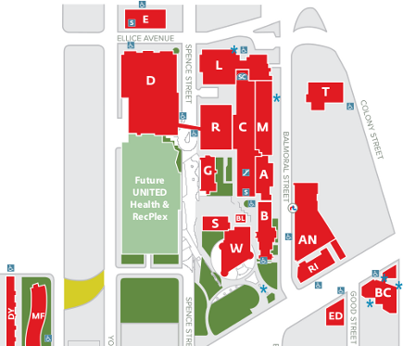
Important: MUUG Has Moved
Our new home is at the University of Winnipeg in Lockhart Hall room 1L07 which is indicated on the map by the “L”. Lockhart Hall is on the south-east corner of Spence and Ellice. Parking is available on the surrounding streets. Look for signage once you’re at the building, or ask a security guard.
Upcoming Meeting

June 11th, 2013
Topic: TBD – Last meeting before summer!
Location: 1L08 Lockhart Hall, U of W

We Want You!
MUUG is always looking for presenters. Do you have a side project that you’ve been aching to show off? Do you just want to do a quick 5 minute demo of some software you found amazing?
Drop the board an email at board@muug.mb.ca and let us know. Any suggestions for topics you’d like to hear are always more than welcome.
Cheat Sheets for Cheaters
A friend (Gilbert!) just put me onto what appears to be the largest collection of “cheat sheets” in the known universe.
OverAPI.com (http://overapi.com) provides access to reference cards on far more languages and applications than I have even heard of. From .NET to Zen coding, Lisp to Python, Gimp to Perforce, Lua to Symfony?, and of course staying on this month’s topic: Perl, PHP, and Python. In fact, there are even cheat sheets on this site for guitar keys, geometry, and probability theory.
The site is actually a series of both pages and links to pages on other sites that has been put together to provide easy access to some of the best reference material available on various languages and systems.
Take the reference card for “regex” (regular expressions) for example. In an attractively formatted page (plus a little more) of groupings, the site provides information on anchors, modifiers, quantifiers, groups and ranges, character classes, assertions, metacharacters, POSIX expressions and string replacement. The examples are also followed by explanations.
When you visit the site, you’ll notice that there are two sections to the material. Icons at the top lead to reference sheets on the site itself, all using the same (very attractive) format. Below this is an organized-by-letter section grouping languages or topics by first letter and generally lead to a page that contains one to many references of material on other sites.
This is all very nice material that might save you a lot of time, especially when you’re starting out with a new language or just want some syntax help now and then.

Full article: http://bit.ly/10wGkjJ

Actual Cheat Sheet Site: http://overapi.com
Linux 3.9 Released
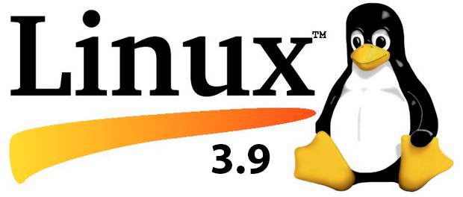
After weeks of RC releases and a week’s delay Linux 3.9, which packs a lot of new features, was finally made available by Linus Torvalds on April 29th, 2013.
One week earlier, Torvalds released the rc8 version (instead of Linux 3.9) stating that he wasn’t “comfy” releasing the final version yet and that “another week won’t hurt”. Torvalds noted in the April 29th announcement that the week before had been very quiet as there were not many commits and the ones which were there were “really tiny” which is why he went ahead with the final release of Linux 3.9.
The wait seems to be very well worth it as the latest kernel of the open source operating systems packs quite a lot of new features that were long awaited. Here is what’s new:
Support for SSD - Linux 3.9 brings with it support for Solid State Drives (SSD). The kernel’s Device mapper has a cache target called “dm-cache”, which enables users to set up one drive as a cache for another one. A good example here would be setting up of SSD as cache for an HDD. SSDs can cache the data allowing for faster data writes and when the system is not busy doing much, data can be moved over to slower hard drive. The feature is still labelled experimental but, a new development none the less.
Multiple Sockets listen on Same Port - A new option, SO_REUSEPORT, is now supported by both TCP and UDP sockets allowing them to listen on the same port. This particular approach would help workloads be distributed across all the cores available on the processor. Considering an example, a web server’s processes or threads would be able to open individual sockets to listen on port 80. The kernel will then evenly distribute the connections that come in on this port.
Filesystem Enhancements - The Btrfs filesystem now includes experimental support for RAID 5 and RAID 6 on top of RAID 0 and RAID 1. The reason for having RAID features incorporated within the filesystem is that in the layered approach filesystem and RAID don’t know much about each other’s internals. In case of failure, entire disks wouldn’t need to be replaced as the kernel will exactly know where a failure has occurred. In contrast, the layered approach is not able to access this particular information which meant that the entire volume had to be restored.
Enhanced Graphics Support - Linux 3.9 Kernel now supports Oland graphics chips that are used in 8500 and 8600 Radeon HD Cards. On top of this the kernel also supports AMD Richland APU generation, which is yet to be released. Further the Nouveau driver, meant for the NV40 and NV50 GPUs used on GeForce 6xxx to 9xxx and 1xx to 3xx graphics chips, provides quite a few automatic and manual fan controls.
Drivers, Drivers, Drivers - The Linux 3.9 comes with drivers for Intel’s series 7000 Wi-Fi components; added robustness for HD audio codecs; updates to libata drivers with support for zero power optical device drives (ZPODD); new drivers to support Chromebook from different vendors; driver for Cypress APA I2C trackpads.
Virtualization - 3.9’s KVM hypervisor now comes with support for virtualization features of Cortex A15 processors. Beyond this Linux 3.9 kernel’s Xen support now includes drivers for hotplugging processors and memory components. With integration of the drivers for VMware’s VMCI (Virtual Machine Communication Interface) and the VMCI Sockets, Linux 3.9 brings in more support for VMware’s virtualization solutions.
Managing Power - Linux 3.9 brings with it “lightweight suspend” or “suspend freeze” mode allowing the kernel to put all the hardware components to deepest sleep state. The main difference between the suspend-to-RAM (ACPI S3) and this feature is that this particular mode doesn’t power down the components thereby allowing for a quicker resume. Even though the power consumption is higher than that of the suspend-to-RAM, the suspend freeze mode is designed to consume less power than during the normal idle state as the processor will be in a longer and deep sleep. The new mode is ideal for smartphones and tablets that are less responsive suspend-to-RAM state.

Full article: http://bit.ly/1379yKn
Research explodes myth that older programmers are obsolete
Old dogs can learn new tricks - if they’re allowed to!
There’s a prevailing ethos among IT hirers that younger is better when it comes to programmers, but a study by academics in North Carolina suggests that employers might be missing a trick by not hiring the grizzled veterans of the coding world.
Research into how our brains evolve over time suggests our intelligence functions alter. Younger minds are more able at “fluidic” intelligence – being able to see complex and innovative connections from large data sets – while older brains have ”crystalline” intelligence that’s better at applying experience and long-term learning to solve problems.
IT recruiters typically look for younger, fluidic thinkers (who are coincidentally cheaper and more likely to work long hours on an inspiring project) but the research suggests that adding some crystalline intelligence to programming projects could have serious benefits.
The team used data from the Stack Overflow developer forum’s 1.6 million registered members (300,000 of whom listed their age), and whittled down the sample to 84,284 programmers who were active in 2012 and had decent reputation rankings.
The mean age of the sample base was just over 29, but there is a long tail of older code monkeys who still dispense advice to the young guns. These advisories were tagged and showed that what older developers lacked in numbers they more than made up for in the number of queries correctly answered or problems solved.
The research stemmed from a panel of veteran developers they had a couple of years ago who claimed that everything that’s old is being reinvented again, such as the focus on virtual machines coming from mainframes many years ago.
“Any knowledge that people have of the past should be completely relevant today – even if the technology is ‘new’ there should be knowledge transfer.”
The Stack Overflow data showed that, contrary to perceived wisdom, veteran coders are just as able as young pups to adopt new programming languages, and in some cases they enjoy an advantage. For example, knowledge of C gives them a statistically relevant advantage when it comes to iOS and Windows Phone programming.
Programmers in their 50s and 60s did as well, if not better, than their younger counterparts in some skill ranges, and Dr. Murphy-Hill cited research in Finland showing older coders were adept at picking up new skills. But unfortunately, management practices aren’t helping.
“There’s a perception that older developers are less able to cope with new technologies and the issue is that it’s a self-fulfilling prophecy,” he said.
“If you perceive older developers can’t update to new technology you will put them in roles where they have no opportunity to learn and throw the younger programmers into new training and use older programmers for legacy systems.”

Full arcicle: http://bit.ly/109njoL

