
MUUGLines
The Manitoba UNIX User Group Newsletter
Volume xxxx No. xxxx, Month Year Editor: Your Name Goes Here
Next Meeting: Month DAY, Year

RTFM and presentation:
In the RTFM segment this month, Firstname Lastname will explore the differences between wget(1) and curl(1). Note the use of the MUUG-Code character style, which survives Format-->Clear_Direct_Formatting. There's also a MUUG-Link character style for URLs that compresses the text so it looks reasonable in the middle of a whole bunch of text.
Now talk about the main presentation here. Hopefully there's most of a column's worth... Lorem ipsum dolor sit amet, consectetur adipiscing elit, sed do eiusmod tempor incididunt ut labore et dolore magna aliqua. Ut enim ad minim veniam, quis nostrud exercitation ullamco laboris nisi ut aliquip ex ea commodo consequat. Duis aute irure dolor in reprehenderit in voluptate velit esse cillum dolore eu fugiat nulla pariatur. Excepteur sint occaecat cupidatat non proident, sunt in culpa qui officia deserunt mollit anim id est laborum.
MUUG Mugs!
This is a common filler article, often placed here to force the map into the second column of the first page. It's mostly needed if there isn't much to say about the presentation, but still just enough to cause the map to wrap. Feel free to substitute whatever you can.
Back by popular demand! MUUG now has new coffee mugs, cobalt blue and deep laser-etched with our age old, lovable logo for sale for $15 cash. They are quality mugs, made in the USA, and have a fairly large volume capacity. Want a mug but can’t make meetings? Ask on the mailing list and most likely a board member can deliver one within Winnipeg.
Where to Find the Meeting
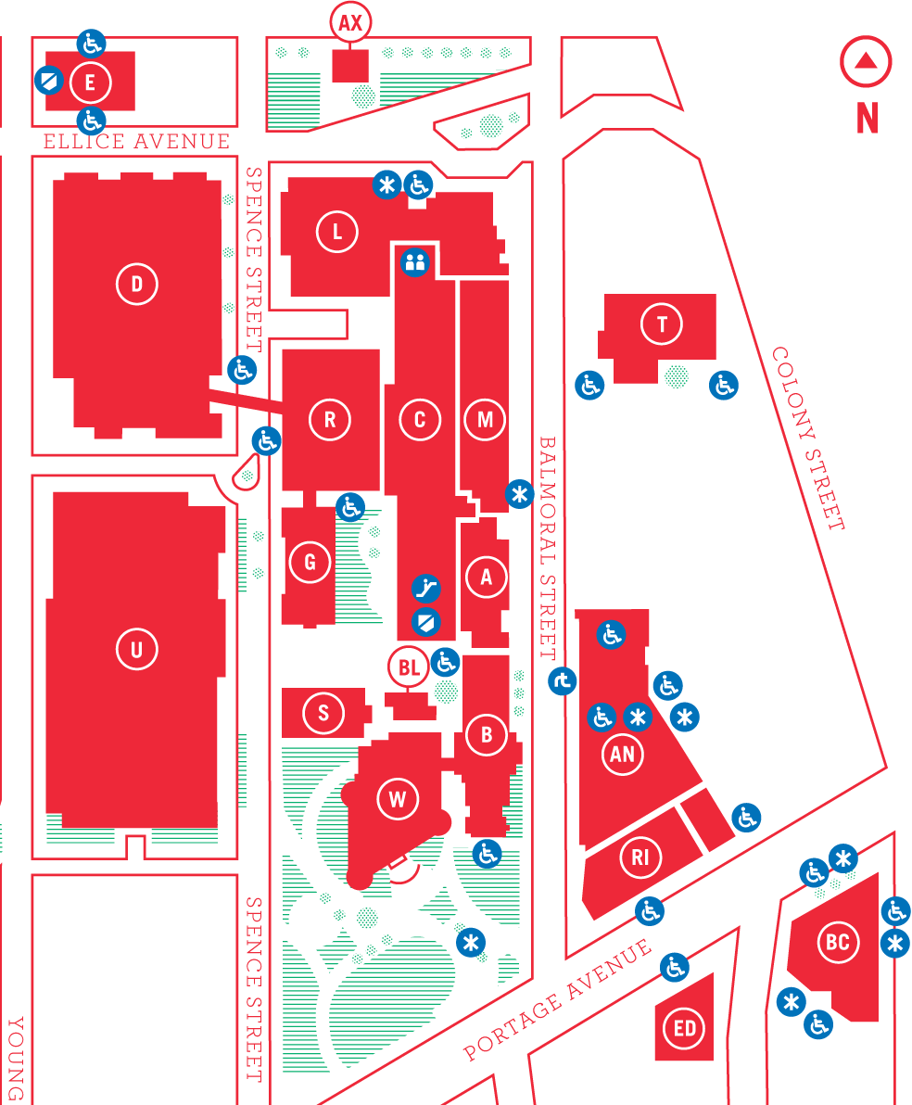
Meetings are held in the University of Winnipeg's Lockhart Hall (marked “L” on the map), at the south-east corner of Spence Street and Ellice Avenue. We can normally be found in room 1L08, but occasionally get relocated to nearby rooms. If there is a change, it should be conveyed via a sign on the door to 1L08. Parking is available on the surrounding streets. Please see http://www.uwinnipeg.ca/maps for further information about parking and access to the campus.
A quotation or short joke can go here to flesh out the second column, if needed..
This uses the MUUG-Quotation style and a line break intsead of a paragraph break.
—Some Dude With a Beard
MUUG-Heading #2 (there's no #1)
Byline, if needed – mostly use this when you want to establish attribution or authorship other than “The Board” as a whole.

MUUG-Heading #3
Lorem ipsum dolor sit amet, consectetur adipiscing elit, sed do eiusmod tempor incididunt ut labore et dolore magna aliqua. Ut enim ad minim veniam, quis nostrud exercitation ullamco laboris nisi ut aliquip ex ea commodo consequat. Duis aute irure dolor in reprehenderit in voluptate velit esse cillum dolore eu fugiat nulla pariatur. Excepteur sint occaecat cupidatat non proident, sunt in culpa qui officia deserunt mollit anim id est laborum.

Another sub-heading
Bullets don't seem to work anymore. Let me know if you want them and I'll fix the style properly.
If you're pasting code, like this:
10 PRINT “Hello”
20 GOTO 10
there's a MUUG-code paragraph style. If you're just calling something out in-line, like telling people to write 20 GOTO 10 in their program, there's a MUUG-code character style instead.
Formatting Articles
This is how you format a link, say to http://www.muug.mb.ca/: copy the URL to the clipboard, then press Ctr+K. Now paste the URL into both the Target and Text fields, then Apply, then Close. (And don't ask me why there's no OK button.) LibreOffice will often do this for you if you just type or paste the URL into the body of the text anyway. Now go back and select the link, and apply the MUUG-Link characte rstyle to it.
Editing this Newsletter

Fonts needed
Linux Libertine O (OTF format, not TTF) – used for most of the text.
Linux Biolinum O (OTF, not TTF) – used for headings.
Droid Sans – used for the main title block.
Droid Sans Mono – used for all monospace text.

Software needed
LibreOffice 4.3.4.1 was used to create this. YMMV.
The Master List of Styles
Adam Thompson

Paragraph
MUUG-Body: use this by default for all text
MUUG-byline: used after MUUG-heading 2 to indicate an author
MUUG-code: used for lines of code or pre-format text (includes indent)
MUUG-Dateline: only used in the Masthead for the Volume/# and Editor line
MUUG-heading 2: used for article titles
MUUG-heading 3: used for in-article subheadings
MUUG-Link: deprecated, used for setting out an entire line of URL text
MUUG-Masthead: only used for the main title
MUUG-Quotation: used to make short quotes, jokes, etc. stand out
MUUG-Sub-mast: because someone (probably me) forgot exactly what a Masthead was when setting up the styles! Used for the sub-title at the beginning of the newsletter

Character
MUUG-code: used for inline code/preformat (e.g. names of commands, programming text, etc.)
MUUG-link: used for inline URLs

Missing styles
If you use something regularly, that you think I've left out, let me know. Ideally, also let me know what newsletter you used it in so I can copy it and verify that it still works correctly.
Errata
Obviously, there will be mistakes even in this template. Let me know and I'll fix them ASAP.
Book & User Group Discounts

O'Reilly
Oops, gotta find the graphic again... it's just an embedded image. Remember to format its Alignment as “As Character” and set a 1pt border.

No Starch Press
There's a graphic that we've used from time to time. I have to find that and put it in here, too. Can be deleted if you need just little more room. Can also be moved wherever it needs to go.
No Starch Press has established a discount for user group members. It’s valid for 30% off everything they publish, and it doesn’t expire. Use “MUUG” as the discount code when ordering from their website.

